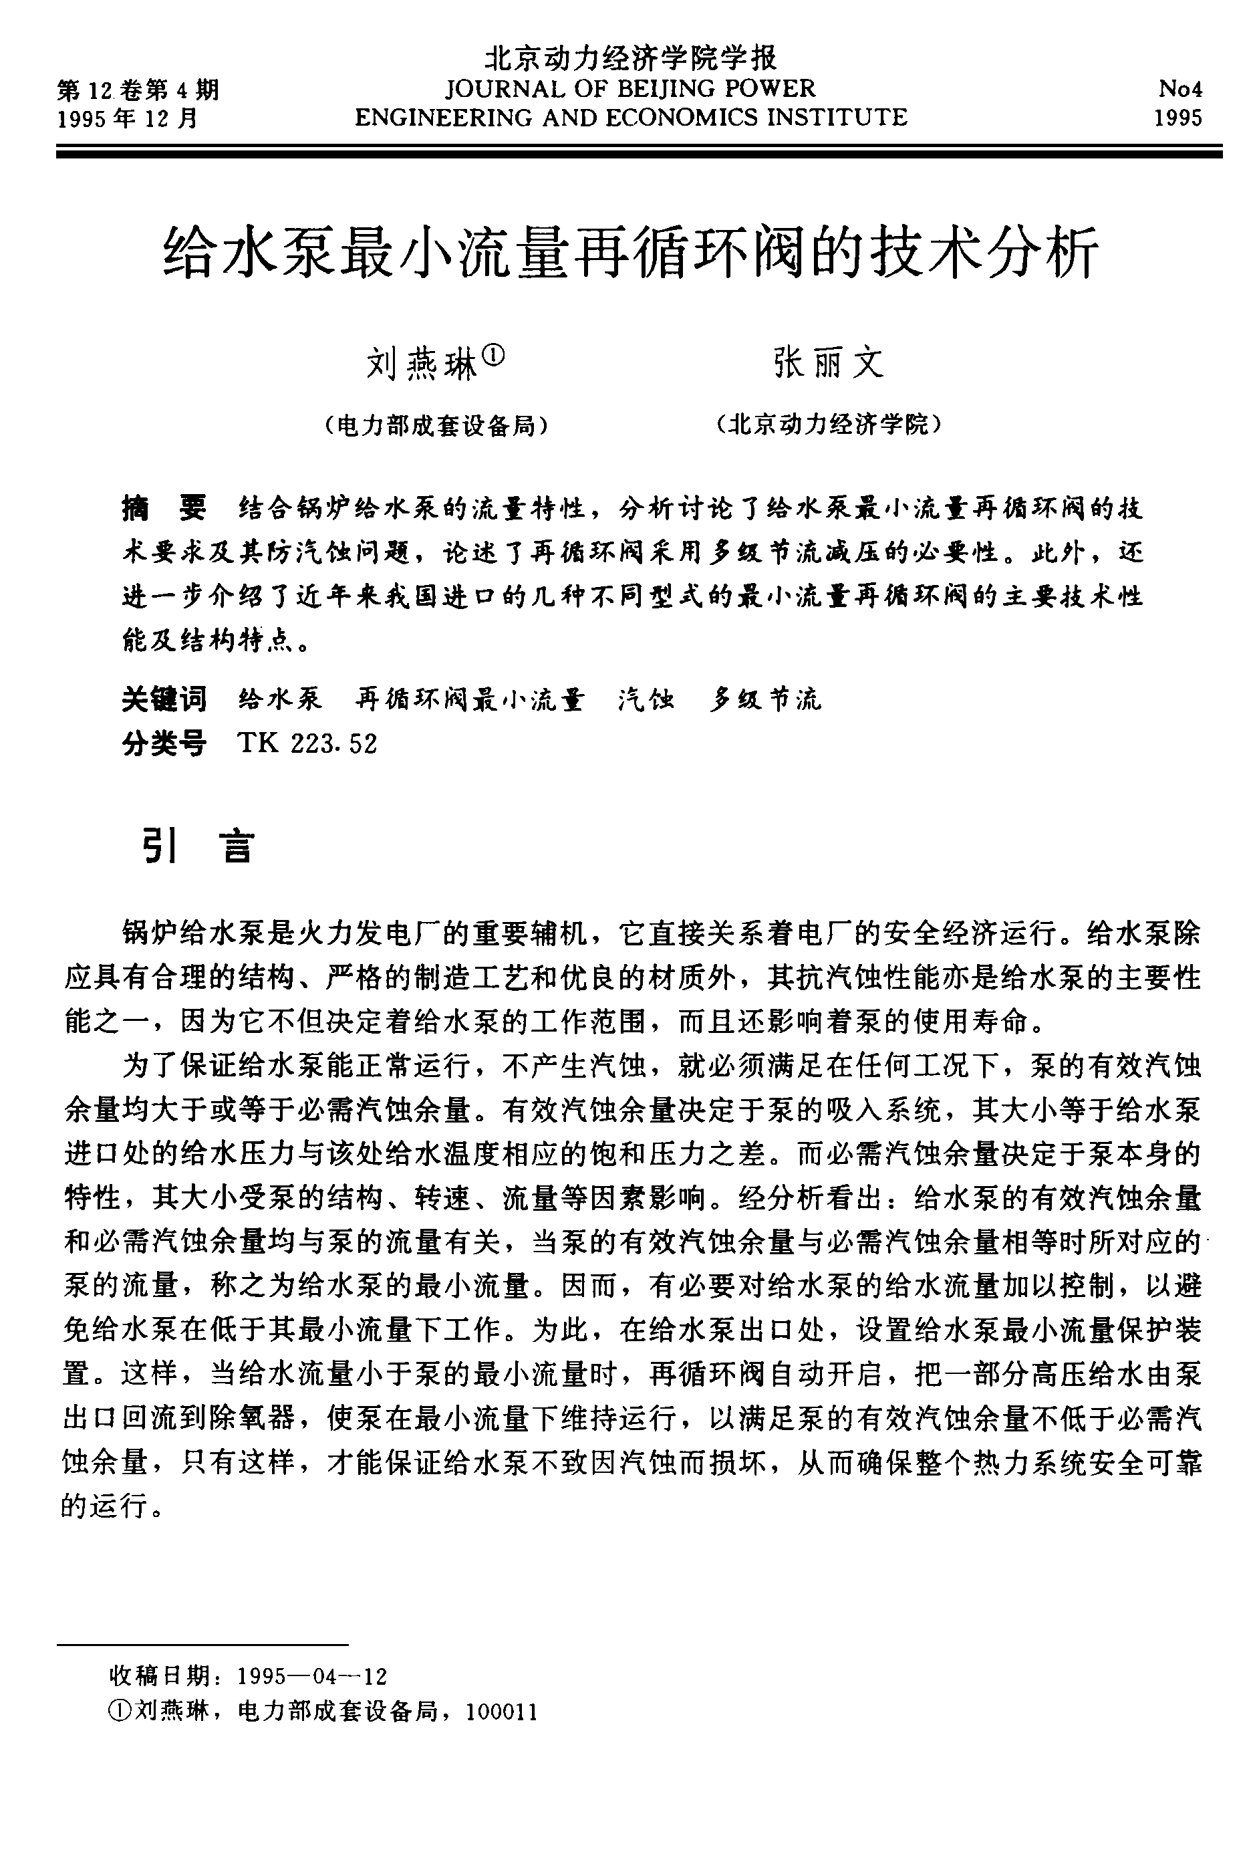

© 1995-2004 Tsinghua Tongfang Optical Disc Co., Ltd. All rights reserved.
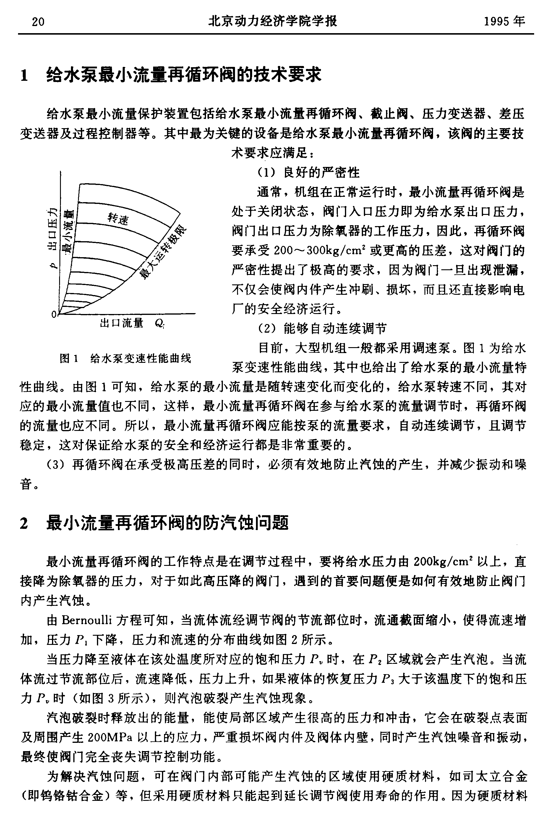

© 1995-2004 Tsinghua Tongfang Optical Disc Co., Ltd. All rights reserved.
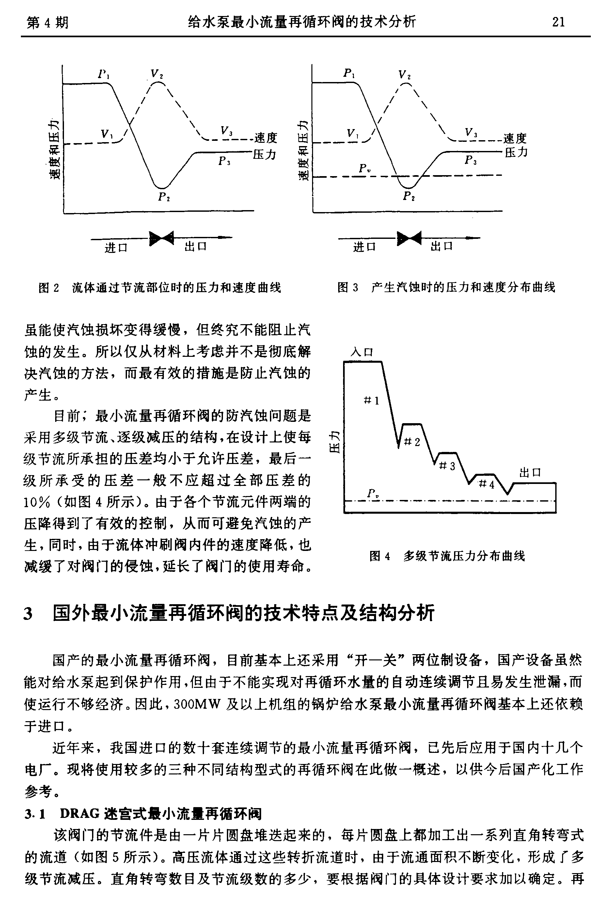

© 1995-2004 Tsinghua Tongfang Optical Disc Co., Ltd. All rights reserved.
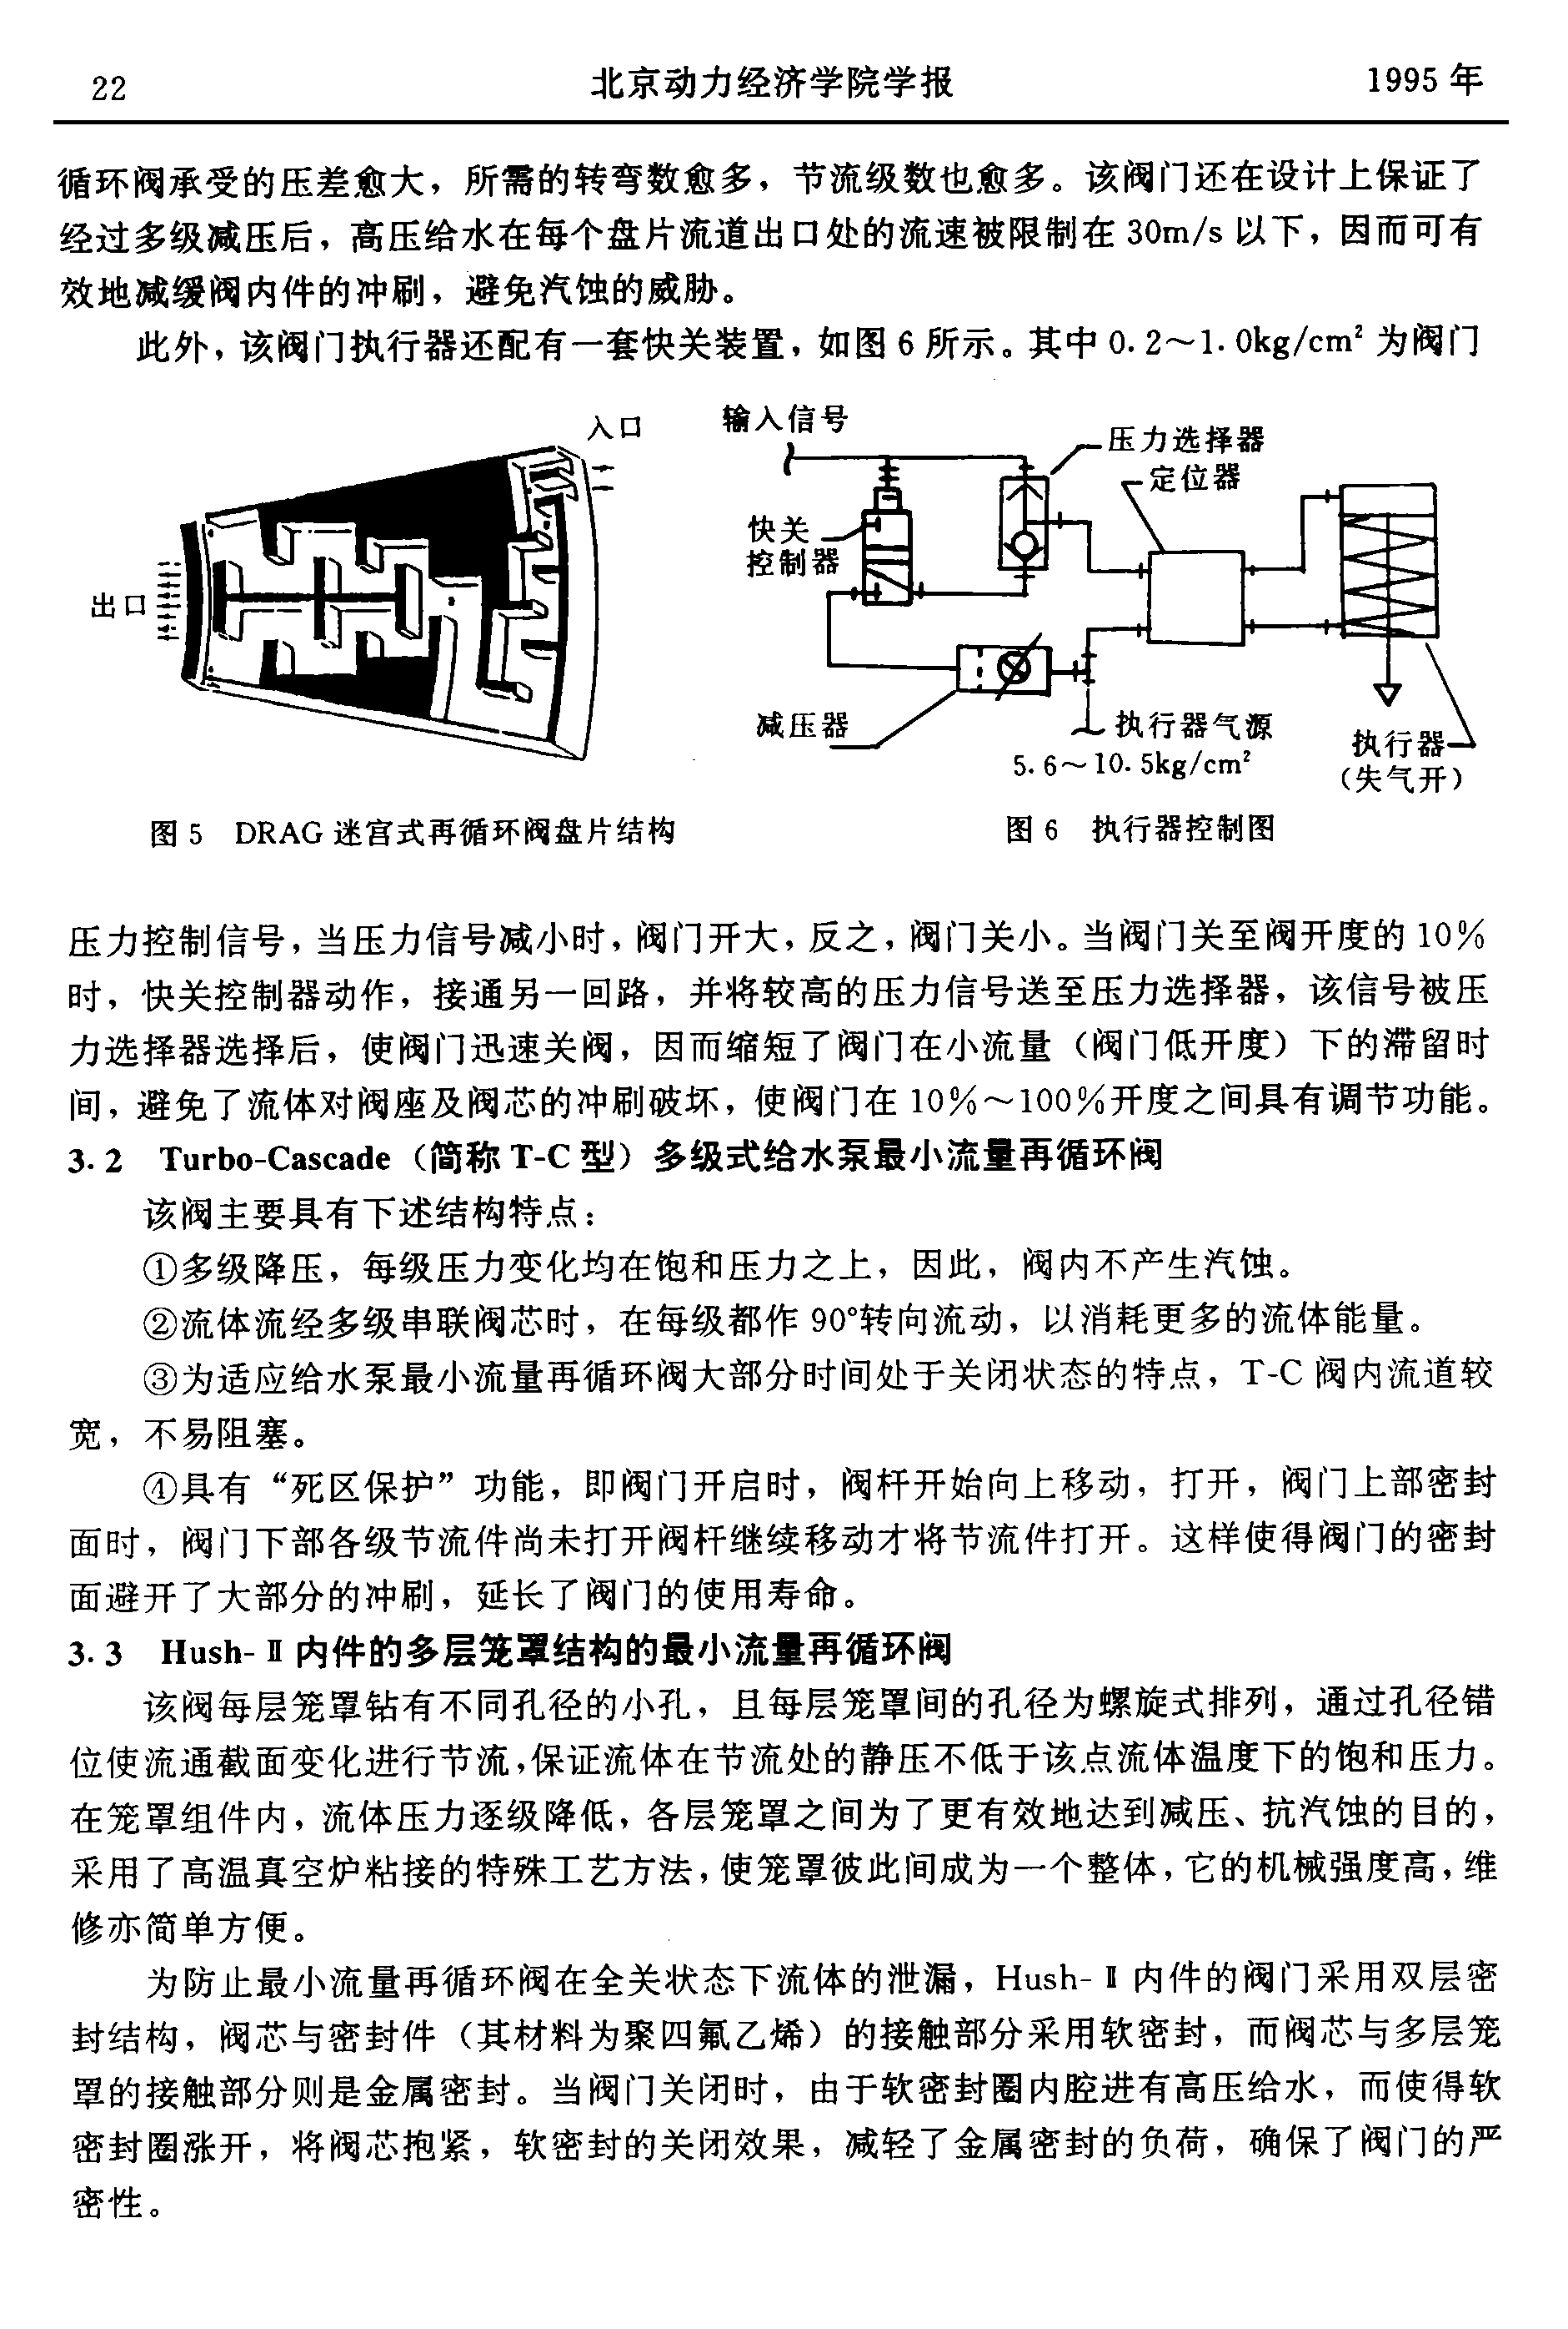

© 1995-2004 Tsinghua Tongfang Optical Disc Co., Ltd. All rights reserved.
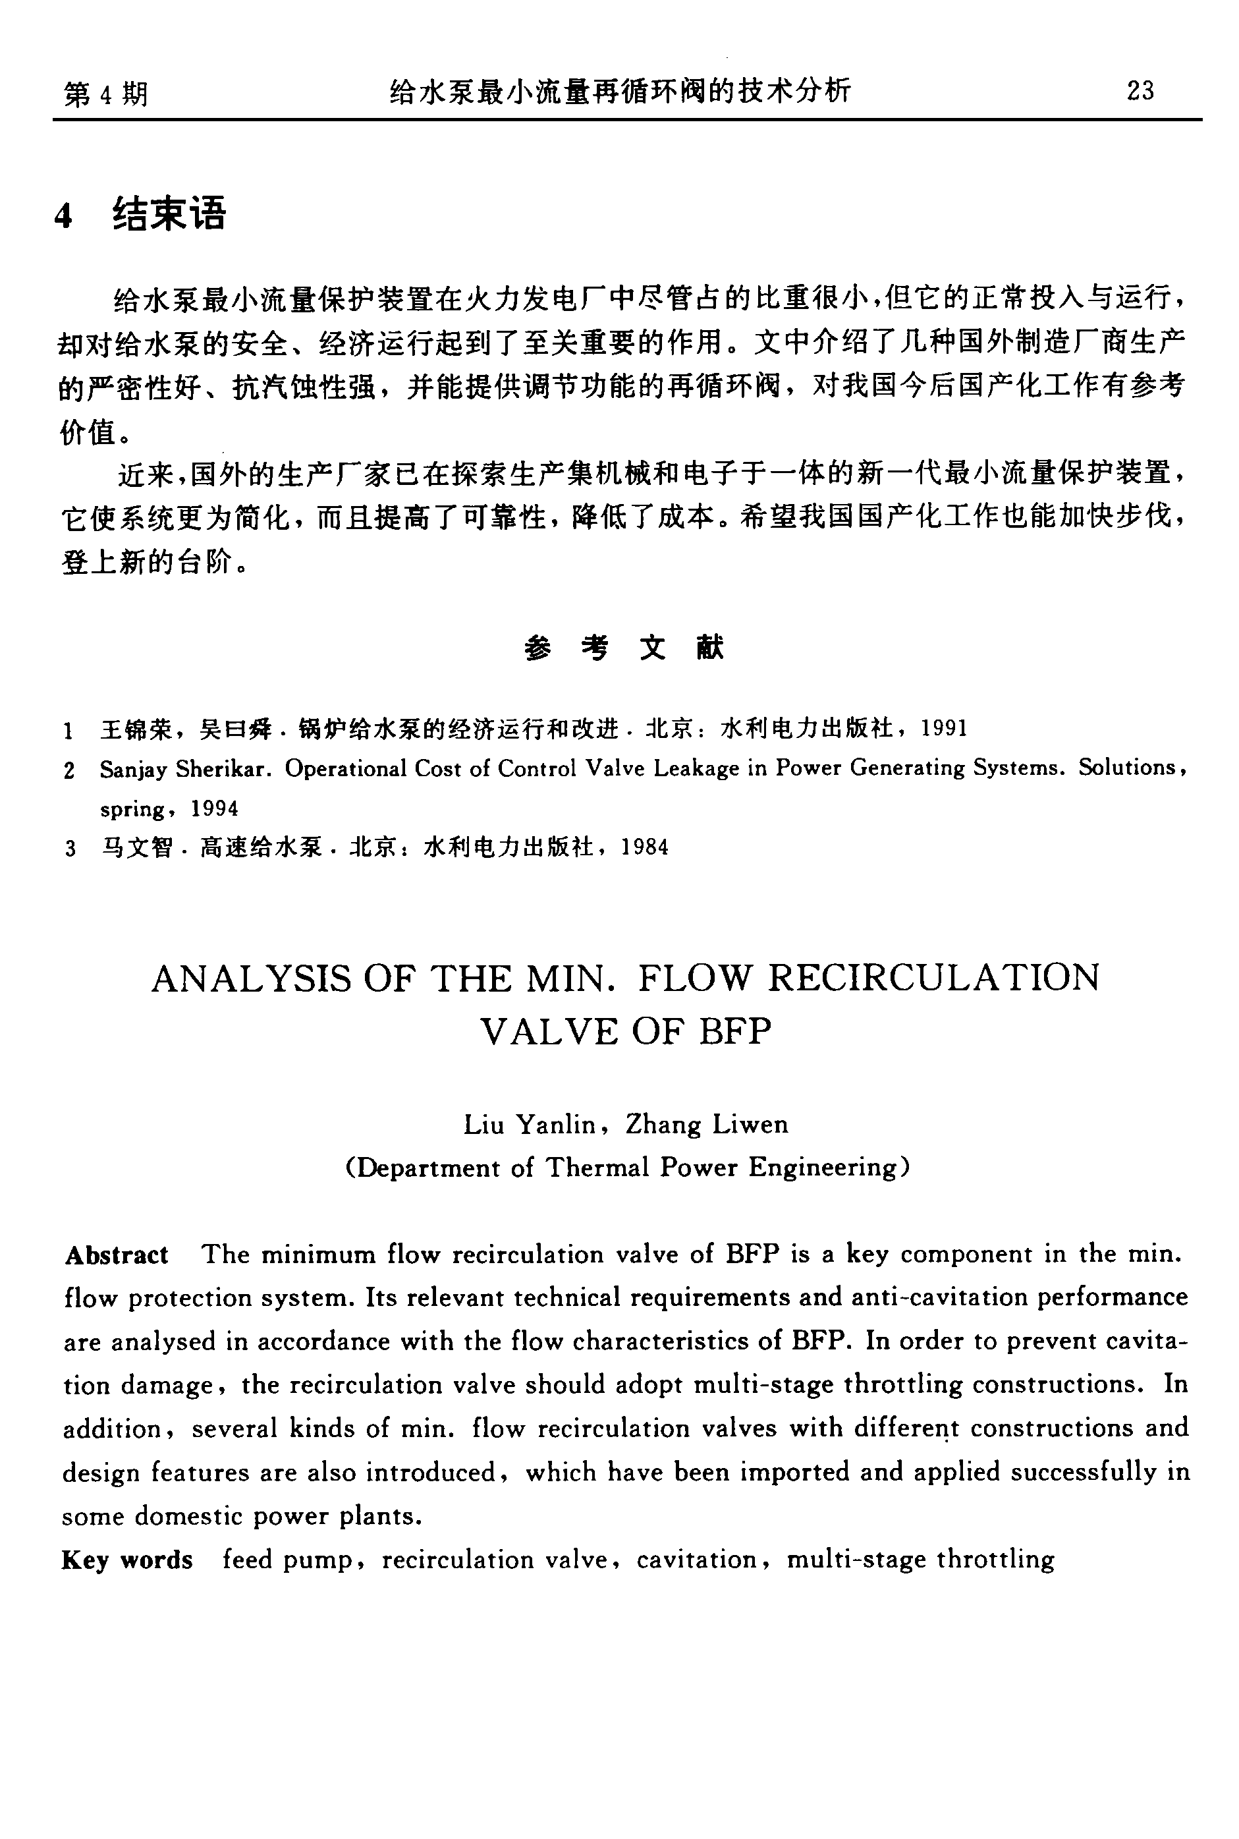

© 1995-2004 Tsinghua Tongfang Optical Disc Co., Ltd. All rights reserved.

